ANOVA Tutorial Sheet Solutions

## QUESTION 1.

Read in data and ;

## Observation Group  
## Min. : 1.000 A:9   
## 1st Qu.: 4.250 B:8   
## Median : 7.000 C:5   
## Mean : 6.455   
## 3rd Qu.: 8.750   
## Max. :11.000

## # A tibble: 3 × 2  
## Group mean_size  
## <fct> <dbl>  
## 1 A 5   
## 2 B 6.5  
## 3 C 9

* ii Child’s height vs father’s height; 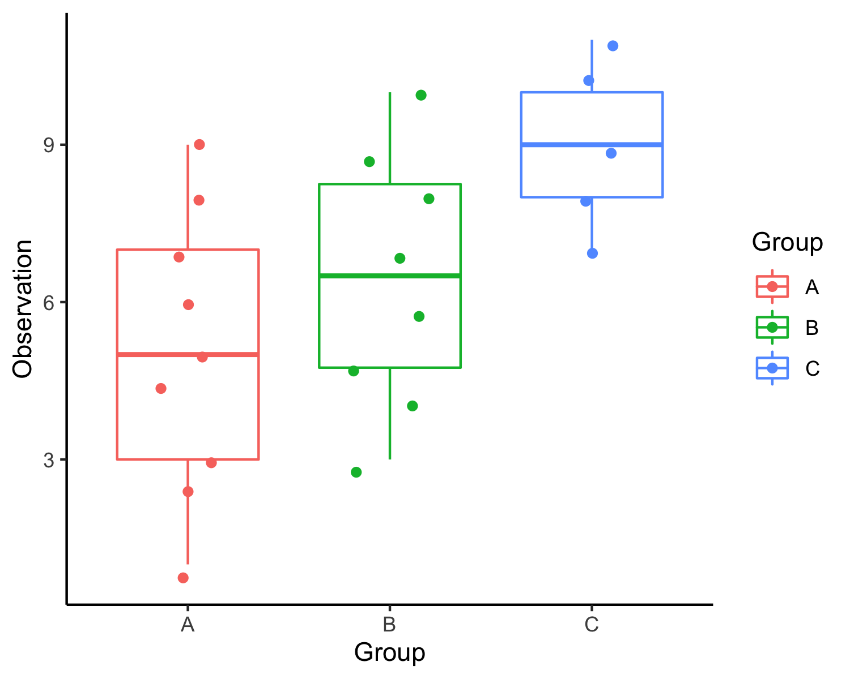

## ANOVA

## Df Sum Sq Mean Sq F value Pr(>F)   
## Group 2 51.45 25.727 4.364 0.0276 *  
## Residuals 19 112.00 5.895   
## ---  
## Signif. codes: 0 '***' 0.001 '**' 0.01 '*' 0.05 '.' 0.1 ' ' 1

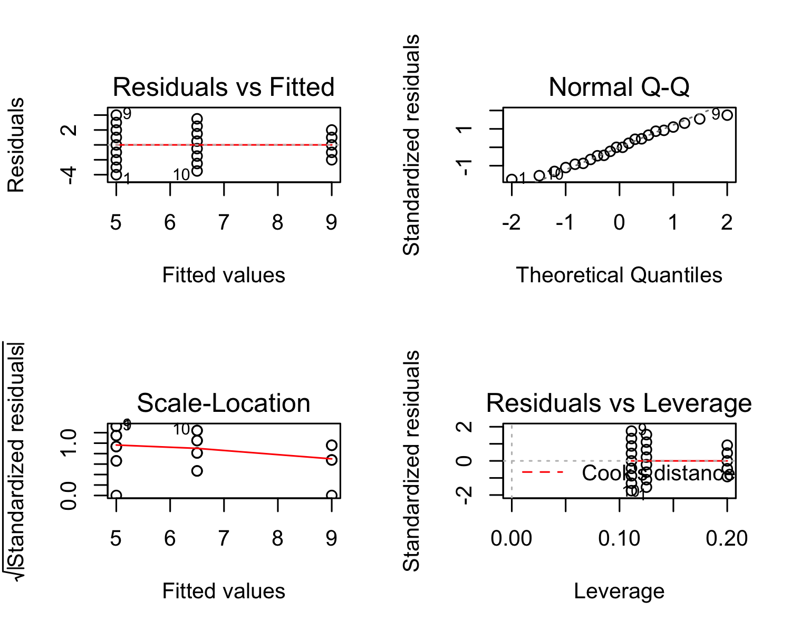

## T-test

### Uncorrected

## Coefficient covariances computed by hccm()

## ANOVA Table (type II tests)  
##   
## Effect DFn DFd F p p<.05 ges  
## 1 Group 2 19 4.364 0.028 * 0.315

| .y. | group1 | group2 | n1 | n2 | p | p.signif | p.adj | p.adj.signif |
| --- | --- | --- | --- | --- | --- | --- | --- | --- |
| Observation | A | B | 9 | 8 | 0.21900 | ns | 0.21900 | ns |
| Observation | A | C | 9 | 5 | 0.00815 | ** | 0.00815 | ** |
| Observation | B | C | 8 | 5 | 0.08680 | ns | 0.08680 | ns |

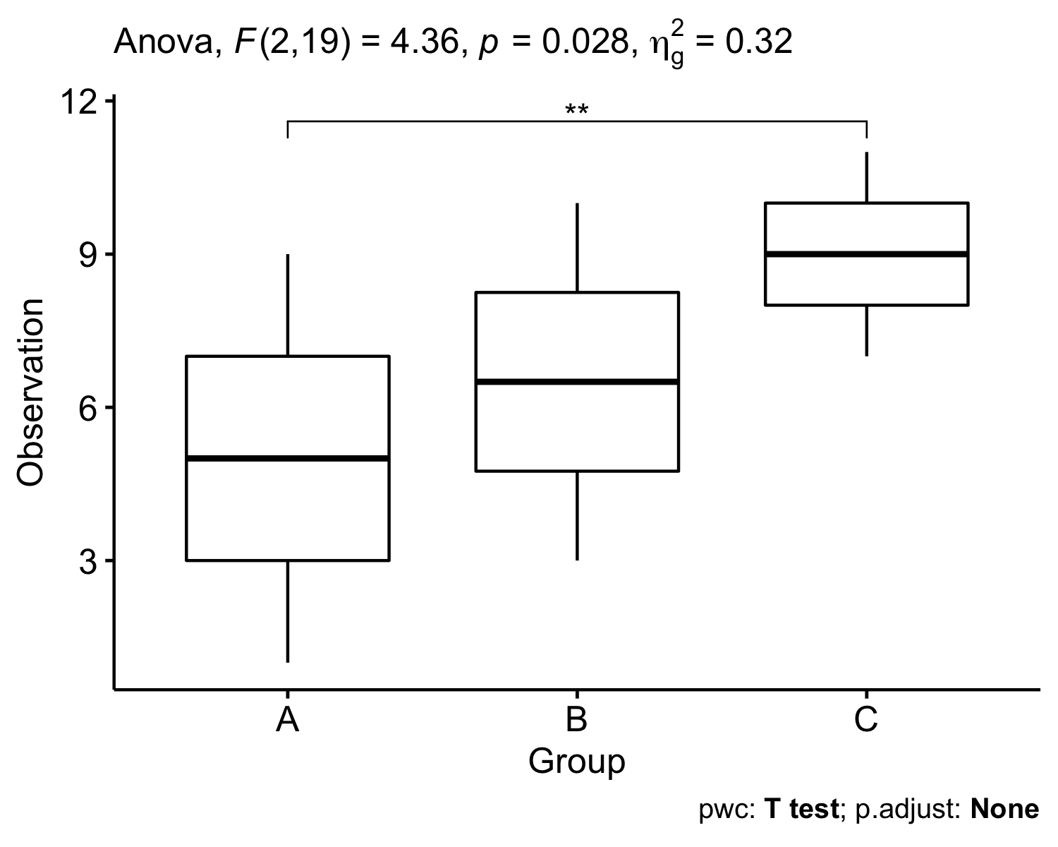

### Bonferonni

| .y. | group1 | group2 | n1 | n2 | p | p.signif | p.adj | p.adj.signif |
| --- | --- | --- | --- | --- | --- | --- | --- | --- |
| Observation | A | B | 9 | 8 | 0.21900 | ns | 0.6570 | ns |
| Observation | A | C | 9 | 5 | 0.00815 | ** | 0.0245 | * |
| Observation | B | C | 8 | 5 | 0.08680 | ns | 0.2600 | ns |

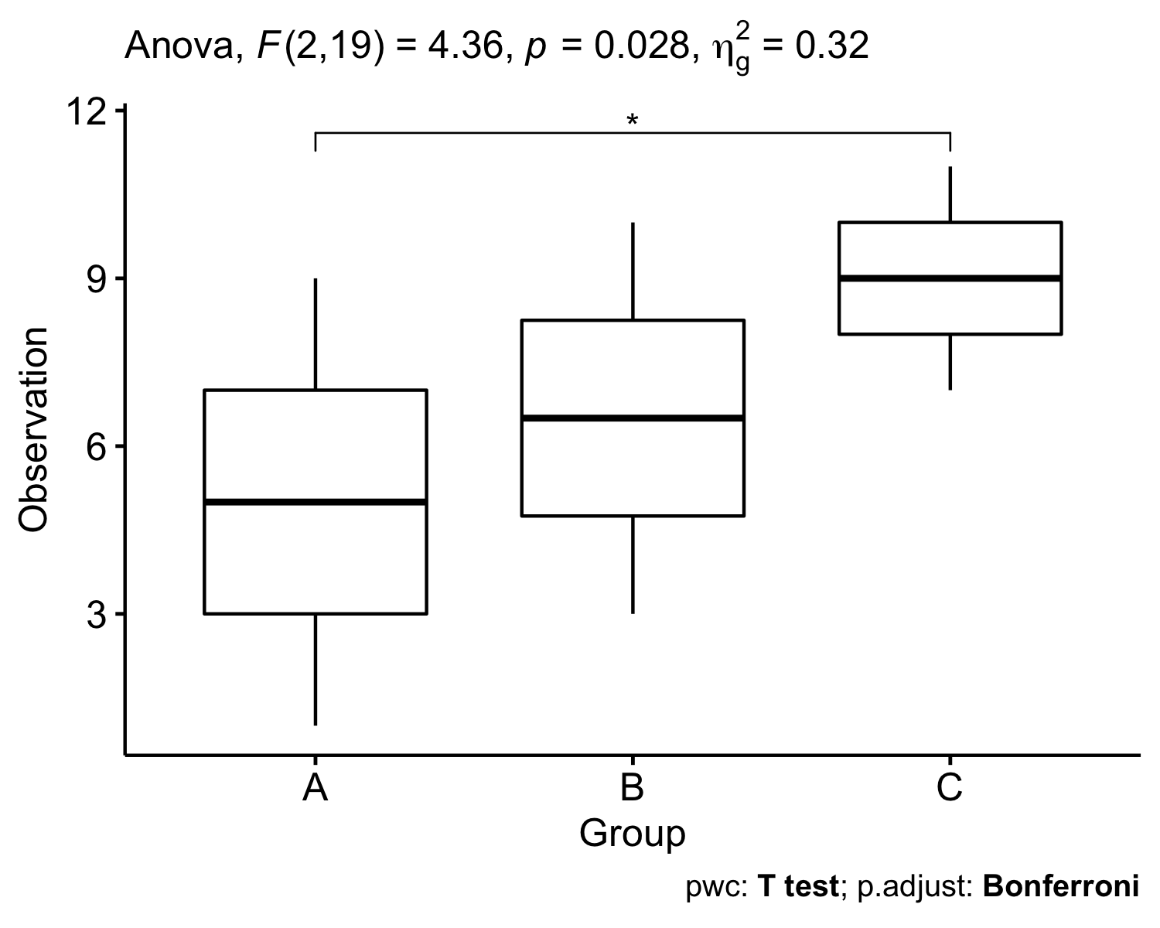

### BH

| .y. | group1 | group2 | n1 | n2 | p | p.signif | p.adj | p.adj.signif |
| --- | --- | --- | --- | --- | --- | --- | --- | --- |
| Observation | A | B | 9 | 8 | 0.21900 | ns | 0.2190 | ns |
| Observation | A | C | 9 | 5 | 0.00815 | ** | 0.0245 | * |
| Observation | B | C | 8 | 5 | 0.08680 | ns | 0.1300 | ns |

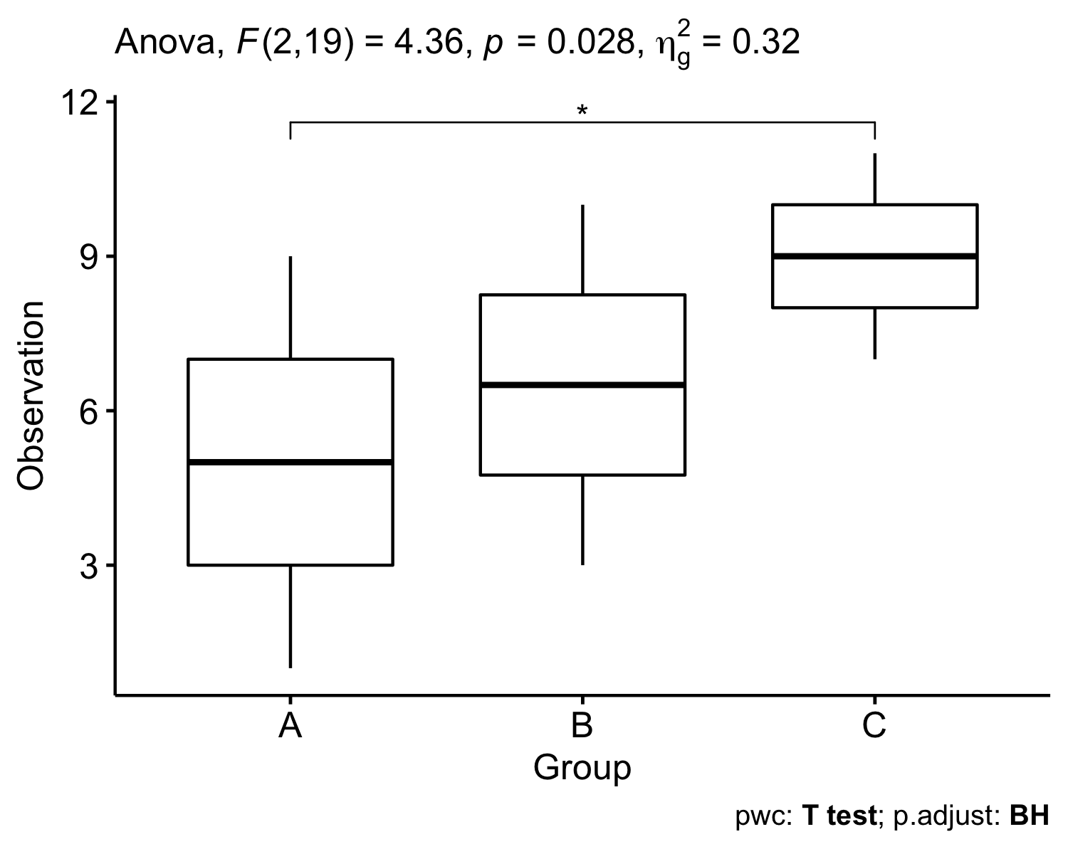

### BY

| .y. | group1 | group2 | n1 | n2 | p | p.signif | p.adj | p.adj.signif |
| --- | --- | --- | --- | --- | --- | --- | --- | --- |
| Observation | A | B | 9 | 8 | 0.21900 | ns | 0.4010 | ns |
| Observation | A | C | 9 | 5 | 0.00815 | ** | 0.0449 | * |
| Observation | B | C | 8 | 5 | 0.08680 | ns | 0.2390 | ns |

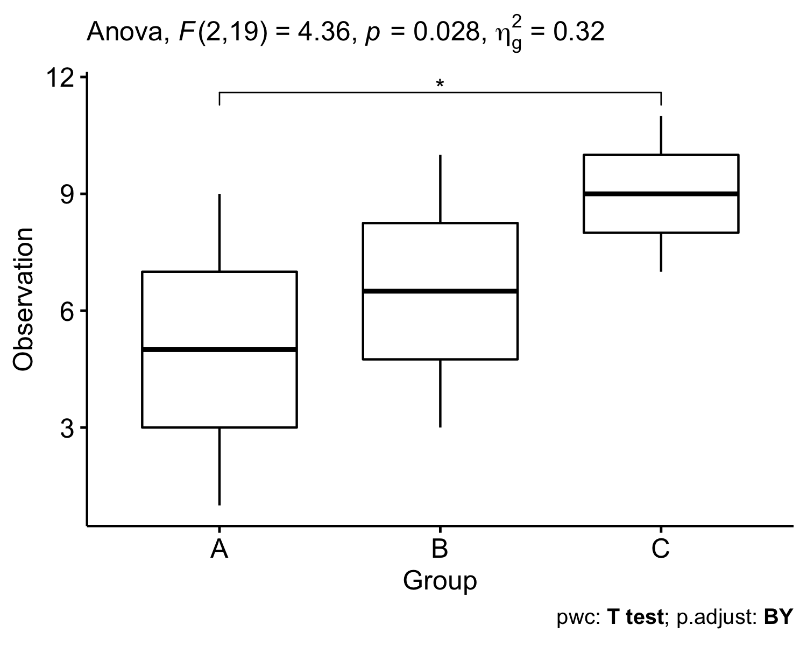

## Tukey Follow Up

$$\left(\overset{‾}{x_{i}}−\overset{‾}{x_{j}}\right)±q_{α,k,N−k}\sqrt{\frac{MSE}{2}(\frac{1}{n_{i}}+\frac{1}{n_{j}})}$$

$$\left(\overset{‾}{x_{B}}−\overset{‾}{x_{A}}\right)±q_{α,3,22−3}\sqrt{\frac{MSE}{2}(\frac{1}{n_{B}}+\frac{1}{n_{A}})}$$

$$\left(6.5−5\right)±q_{α,3,22−3}\sqrt{\frac{5.895}{2}\frac{1}{8}+\frac{1}{9}}$$

## Tukey multiple comparisons of means  
## 95% family-wise confidence level  
##   
## Fit: aov(formula = Observation ~ Group, data = Simple)  
##   
## $Group  
## diff lwr upr p adj  
## B-A 1.5 -1.4970989 4.497099 0.4277742  
## C-A 4.0 0.5596659 7.440334 0.0212316  
## C-B 2.5 -1.0162889 6.016289 0.1943865

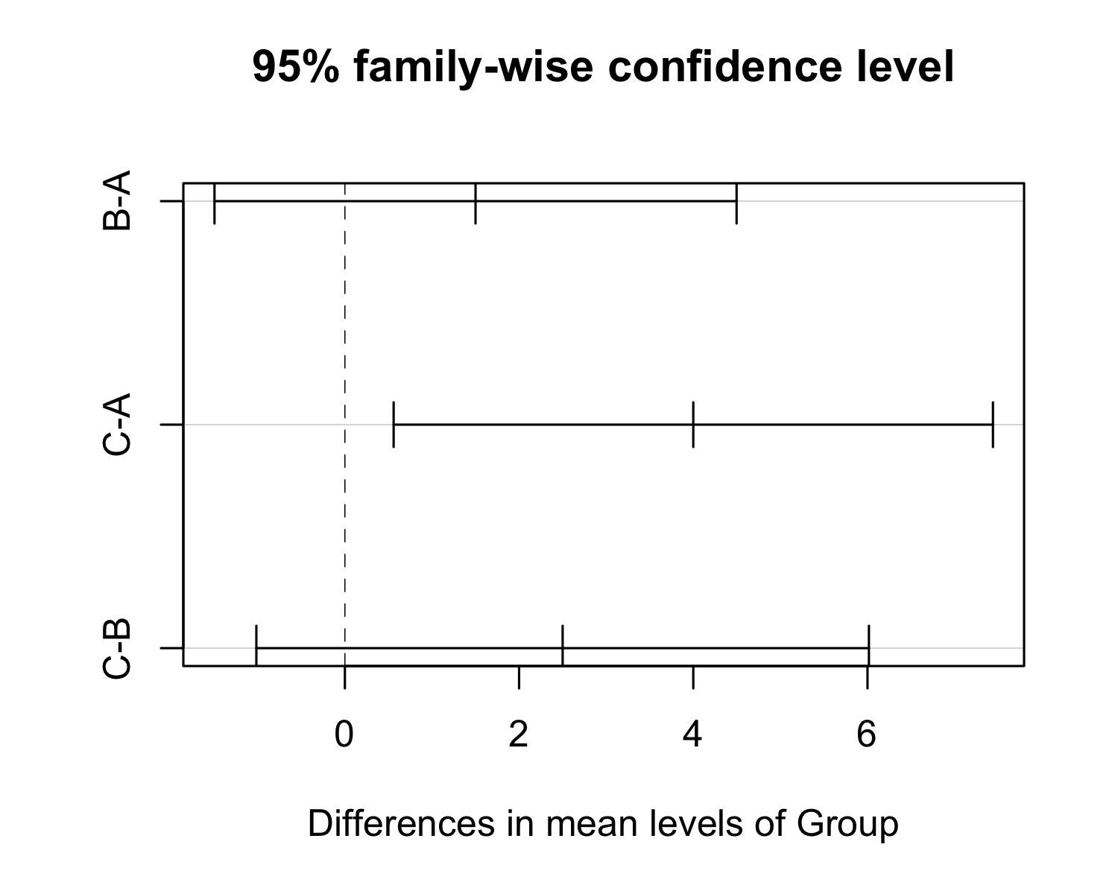

## [1] -1.497166

## [1] 4.497166

## t-test

## Coefficient covariances computed by hccm()

## ANOVA Table (type II tests)  
##   
## Effect DFn DFd F p p<.05 ges  
## 1 Group 2 19 4.364 0.028 * 0.315

| term | group1 | group2 | null.value | estimate | conf.low | conf.high | p.adj | p.adj.signif |
| --- | --- | --- | --- | --- | --- | --- | --- | --- |
| Group | A | B | 0 | 1.5 | -1.4970989 | 4.497099 | 0.4280 | ns |
| Group | A | C | 0 | 4.0 | 0.5596659 | 7.440334 | 0.0212 | * |
| Group | B | C | 0 | 2.5 | -1.0162889 | 6.016289 | 0.1940 | ns |

